|  |
| --- |
|  |
| Capstone Project Document |

**Outsourcing Human Resource Management**

Report #2 – Data Design

|  |  |  |
| --- | --- | --- |
| **Dandelion** | | |
| **Group Members** | Nguyễn Hữu Phước | SE61138 |
| Nguyễn Thị Xuân Mai | SE60910 |
| Ngô Trắc Kiện | SE61016 |
| Trần Quốc Hiệp | SE60928 |
| Đỗ Thanh Dương | SE61191 |
| **Supervisor** | Mr. Nguyễn Văn Sang | |
| **Project code** | OHRM | |

**- Hanoi, 01/2016 –**

# SIGNATURE PAGE

AUTHOR: Nguyễn Thị Xuân Mai 26/01/2016

Team member

REVIEWERS: Nguyễn Hữu Phước --/--/--16

Project manager

APPROVAL: Nguyễn Văn Sang --/--/--16

Supervisor

Record of change

*A - Added M - Modified D – Deleted

|  |  |  |  |  |  |
| --- | --- | --- | --- | --- | --- |
| Effective Date | Changed Item | A,M,D | Change Description | Reason for Change | Rev. Number |
| 26/Jan/20â | Create Data Design | A | Create Data Design | First version | 1.0 |
|  |  |  |  |  |  |
|  |  |  |  |  |  |
|  |  |  |  |  |  |
|  |  |  |  |  |  |
|  |  |  |  |  |  |
|  |  |  |  |  |  |
|  |  |  |  |  |  |
|  |  |  |  |  |  |
|  |  |  |  |  |  |
|  |  |  |  |  |  |
|  |  |  |  |  |  |
|  |  |  |  |  |  |
|  |  |  |  |  |  |
|  |  |  |  |  |  |
|  |  |  |  |  |  |
|  |  |  |  |  |  |
|  |  |  |  |  |  |
|  |  |  |  |  |  |
|  |  |  |  |  |  |
|  |  |  |  |  |  |
|  |  |  |  |  |  |
|  |  |  |  |  |  |
|  |  |  |  |  |  |

Table Contents

SIGNATURE PAGE 1

1 INTRODUCTION 3

1.1 Purpose 3

1.2 Acronyms and Definitions 3

1.3 References 3

1.4 Overview 3

2 Database 4

2.1 Entity Relationship Diagram 4

2.1.1 Entity description 5

2.1.2 Relationship 5

2.2 Table Diagram 7

2.2.1 Role 8

2.2.2 Rank 8

2.2.3 Engineer 8

2.2.4 Account 9

2.2.5 Request detail 9

2.2.6 Project member 9

2.2.7 Project skill 10

2.2.8 Recruitment 10

2.2.9 Project 10

2.2.10 Skill 11

2.2.11 Engineer skill 11

2.2.12 Resource plan 11

# INTRODUCTION

## Purpose

Fly Away Plus data design document describes structure of database and file structure of system including internal file structure as well as interface file structure.

## Acronyms and Definitions

|  |  |
| --- | --- |
| Acronym & Abbreviation | Definition |
| OHRM | Outsourcing Human Resource Management |
| FU | FPT University |
| Q&A | Question and Answer |

Table 1‑1: Acronyms and Definitions

## References

|  |  |
| --- | --- |
| Document | Title |
| Class Design Document | OHRM_Class Design_v1.0_EN |
| Architecture Design | OHRM _Architecture Design_v1.0_EN |
| Software Requirement Specification | OHRM _Software Requirement Specification_v1.0_EN |

Table 1‑2: References

## Overview

This document describes relationship between entities and properties of each entity.

# Database

## Entity Relationship Diagram

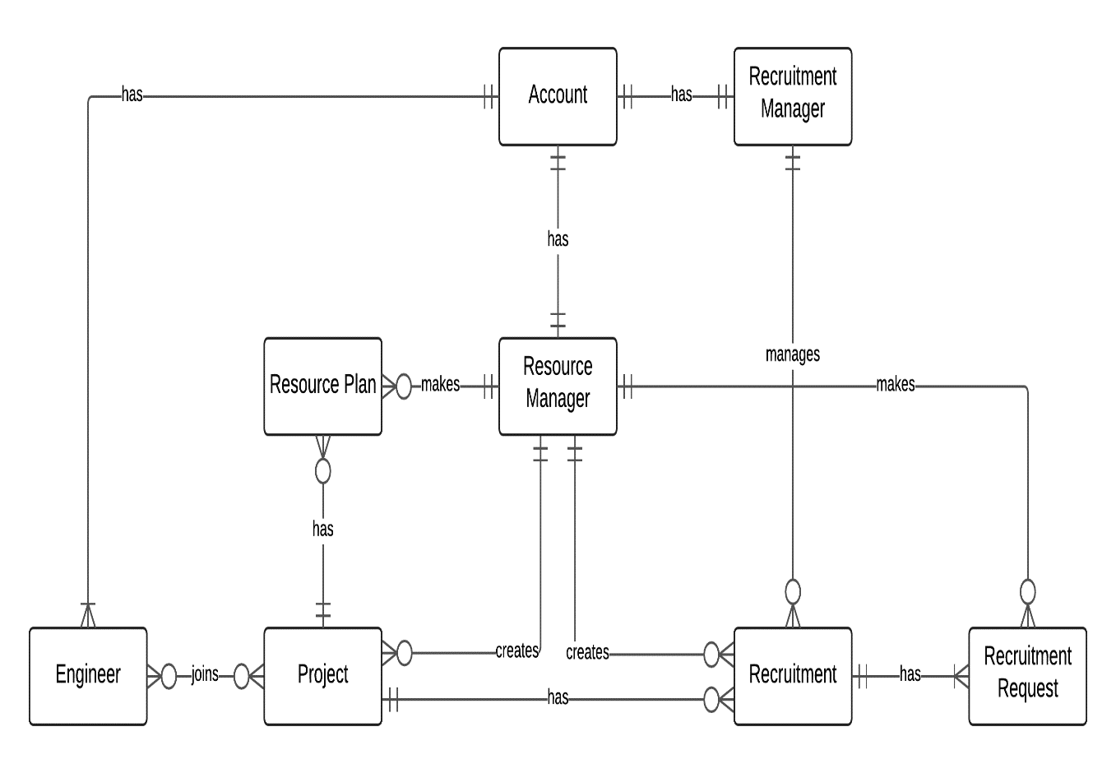

**Figure 2‑1:** Entity Relationship Diagram

### Entity description

|  |  |  |
| --- | --- | --- |
| No | Entity | Description |
|  | Account | People with authenticated access to system |
|  | Resource Manager | A person who manage project, recruitment, report … |
|  | Recruitment manager | A person who responsible for recruiting new Engineer |
|  | Engineer | Resource of company |
|  | Project | A project which resource manager create, includes content detail, assign engineer … |
|  | Resource plan | Resource manager plan resource for project |
|  | Recruitment | When there is lack of resource, resource manager will request recruitment |
|  | Request detail | Each specific Information detail for recruitment |

**Table 2-3:** Entity description

### Relationship

|  |  |  |  |  |  |
| --- | --- | --- | --- | --- | --- |
| No | Relation | Properties | From | To | Description |
|  | HAS |  | Engineer | Account | Engineer has account |
|  | HAS |  | Recruitment manager | Account | Recruitment manager has account |
|  | HAS |  | Resource manager | Account | Resource manager has account |
|  | MANAGE |  | Recruitment manager | Recruitment | Recruitment manager manages recruitment |
|  | MAKE |  | Resource manager | Resource plan | Resource manager makes resource plan |
|  | MAKE |  | Resource manager | Recruitment request | Resource manager makes recruitment request |
|  | HAS |  | Project | Resource plan | Project has Resource plan |
|  | CREATE |  | Resource manager | Project | Resource manager creates project |
|  | CREATE |  | Resource manager | Recruitment | Resource manager creates recruitment |
|  | HAS |  | Project | Recruitment | Project has recruitment |
|  | HAS |  | Recruitment | Recruitment request | Recruitment has recruitment request |

Table 2‑1: Relationship description

## Table Diagram

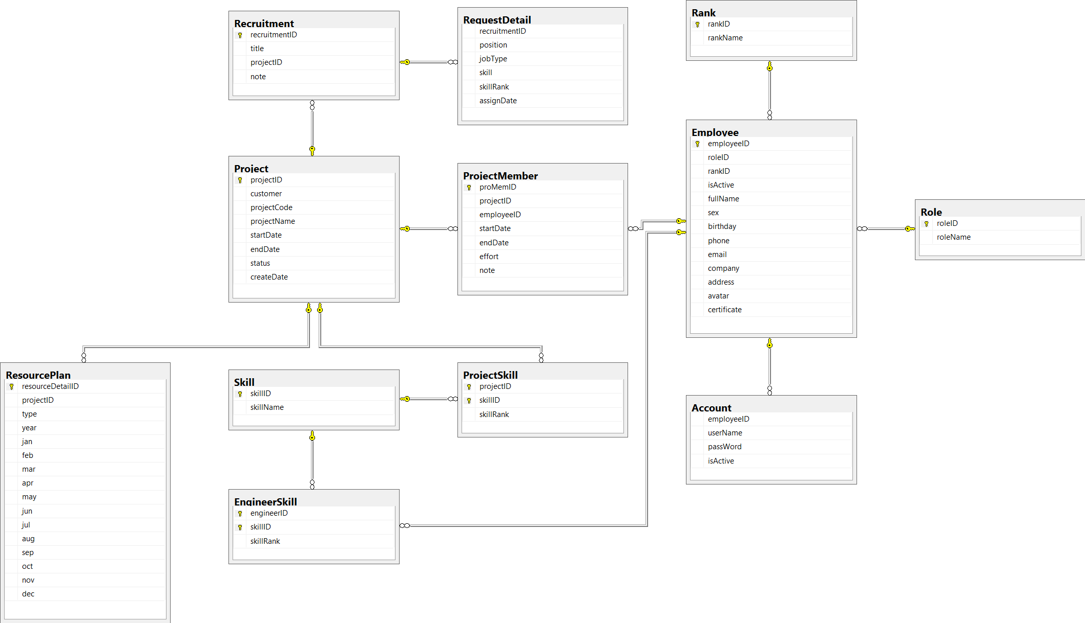

**Figure 2‑2:** Table Diagram

### Role

|  |  |  |  |  |
| --- | --- | --- | --- | --- |
| **No** | **Field Name** | **Type** | **Allow Null** | **Description** |
|  | RoleID | int | No | Role’s ID |
|  | Rolename | String | No | Role’s name |

Table 2‑2: Role

### Rank

|  |  |  |  |  |
| --- | --- | --- | --- | --- |
| **No** | **Field Name** | **Type** | **Allow Null** | **Description** |
|  | rankID | int | No | Rank’s ID |
|  | rankName | String | No | Rank’s name |

Table 2‑2: Rank

### Engineer

|  |  |  |  |  |
| --- | --- | --- | --- | --- |
| **No** | **Field Name** | **Type** | **Allow Null** | **Description** |
|  | EngineerID | int | No | Engineer’s ID |
|  | roleID | int | No | Engineer’s role ID |
|  | rankID | int | Yes | Engineer’s rank ID |
|  | fullName | String | Yes | Engineer’s full name |
|  | sex | bit | Yes | Engineer’s sex |
|  | birthday | date | Yes | Engineer’s birthday |
|  | phone | String | Yes | Engineer’s phone |
|  | email | String | Yes | Engineer’s email |
|  | address | String | Yes | Engineer’s address |
|  | avatar | String | Yes | Engineer’s avatar |
|  | certificate | String | Yes | Engineer’s certificate |

Table 2‑3: Engineer

### Account

|  |  |  |  |  |
| --- | --- | --- | --- | --- |
| **No** | **Field Name** | **Type** | **Allow Null** | **Description** |
|  | EngineerID | int | No | Engineer’s ID |
|  | userName | String | Yes | Account’s username |
|  | passWord | String | Yes | Account’s password |
|  | isActive | bit | Yes | Account’s status |

Table 2‑4: Account

### Request detail

|  |  |  |  |  |
| --- | --- | --- | --- | --- |
| **No** | **Field Name** | **Type** | **Allow Null** | **Description** |
|  | recruitmentID | int | No | Recruitment’s ID |
|  | position | String | Yes | Request detail’s position |
|  | jobType | String | Yes | Request detail’s job type |
|  | skill | String | Yes | Request detail’s skill |
|  | skillRank | String | Yes | Request detail’s skill rank |
|  | assignDate | date | Yes | Request detail’s assign date |

Table 2‑5: Request detail

### Project member

|  |  |  |  |  |
| --- | --- | --- | --- | --- |
| **No** | **Field Name** | **Type** | **Allow Null** | **Description** |
|  | proMemID | int | No | Project member’s ID |
|  | projectID | int | No | Project’s ID |
|  | employeeID | int | No | Employee’s ID |
|  | startDate | date | Yes | Project member’s start date |
|  | endDate | date | Yes | Project member’s end date |
|  | effort | float | Yes | Project member’s effort |
|  | note | String | Yes | Project member’s note |

Table 2‑6: Project member

### Project skill

|  |  |  |  |  |
| --- | --- | --- | --- | --- |
| **No** | **Field Name** | **Type** | **Allow Null** | **Description** |
|  | projectID | int | No | Project skill’s ID |
|  | skillID | int | No | Skill’s ID |
|  | skillRank | int | Yes | Skill’s rank |

Table 2‑8: Project skill

### Recruitment

|  |  |  |  |  |
| --- | --- | --- | --- | --- |
| **No** | **Field Name** | **Type** | **Allow Null** | **Description** |
|  | recruitmentID | int | No | Recruitment’s ID |
|  | title | String | Yes | Recruitment’s title |
|  | projectID | int | Yes | Project’s ID |
|  | note | String | Yes | Recruitment’s note |

Table 2‑9: Recruitment

### Project

|  |  |  |  |  |
| --- | --- | --- | --- | --- |
| **No** | **Field Name** | **Type** | **Allow Null** | **Description** |
|  | projectID | int | No | Project’s ID |
|  | customer | String | No | Project’s customer |
|  | projectCode | String | No | Project’s code |
|  | projectName | String | No | Project’s name |
|  | startDate | date | No | Project’s start date |
|  | endDate | date | No | Project’s end date |
|  | status | String | Yes | Project’s status |
|  | createDate | date | Yes | Project’s create date |

Table 2‑10: Project

### Skill

|  |  |  |  |  |
| --- | --- | --- | --- | --- |
| **No** | **Field Name** | **Type** | **Allow Null** | **Description** |
|  | skillID | int | No | Skill’s ID |
|  | skillName | String | Yes | Skill’s name |

Table 2‑11: Skill

### Engineer skill

|  |  |  |  |  |
| --- | --- | --- | --- | --- |
| **No** | **Field Name** | **Type** | **Allow Null** | **Description** |
|  | engineerID | int | No | Enginner’s ID |
|  | skillID | int | No | Skill’s ID |
|  | skillRank | int | No | Skill’s rank |

Table 2‑12: Engineer skill

### Resource plan

|  |  |  |  |  |
| --- | --- | --- | --- | --- |
| **No** | **Field Name** | **Type** | **Allow Null** | **Description** |
|  |  |  |  |  |
|  |  |  |  |  |
|  |  |  |  |  |
|  |  |  |  |  |
|  |  |  |  |  |
|  |  |  |  |  |
|  |  |  |  |  |
|  |  |  |  |  |
|  |  |  |  |  |
|  |  |  |  |  |
|  |  |  |  |  |
|  |  |  |  |  |

Table 2‑13: Resource plan